Date Submitted: 2/3/2015

**EECS 360**

**Introduction to MATLAB**

**Lab report #1**

Murtha, Daniel

KUID: 2213976

Objective:

The purpose of this lab was to introduce the basic concepts and functionality of Matlab. Matlab, or matrix laboratory, is a numerical computing environment that excels in matrix based computing. Being a high level and, generally, interpreted programming language, Matlab is a quick and powerful way to perform complex mathematics and simulations.

Description:

Matlab is able to be operated from the command line for simple commands and function. Additionally, Matlab commands can be written into a script and stored as a .m file. Data which is normally stored for later is stored in .mat files. The .mat files can be called by console commands as well as Matlab scripts from .m files.

Basic Matlab functions and operators can range from algebra operators such as +, -, *, /, ^, sqrt, . (), and [] to plotting commands such as plot, bar, stem, mesh, and polar

Matlab also has preset constants for values such as pi (π) or i to represent $\sqrt{-1}$.

Additionally, any questions about a Matlab function or method can be answered by entering “help funcitonname” into the command prompt.

Results:

In Lab Questions:

Slide 20) r(4) = 165

Slide 21) How would you create the vectors [2,9,16,23,30] and [9,7,5,3,1]

V =(2:7:30)

X = (9:-2:1)

Slide 22) Why might this method of line vectors be preferred sometimes.

V = (0, 50, 100)

This could be preferred sometimes if you need a smooth, high resolution increase/decrease from one value to another.

Slide 23) V(3) = 9

Slide 24) v(2:4) = 6 9 12

Slide 25) The command will throw an out of bounds error and this is fixed by either extending the vector to 6 indices or changing the v([1 2 6]) to v([1 2 5])

Slide 26)

1

2

3

4

5

Slide 27) newvec = 1 3 5 7 9 3 6 9 12 15

Conclusion:

In conclusion, the lab covered many aspects to the basic functions of Matlab. Being an interpreted, high level language focused on matrix operations, Matlab is a powerful tool for course such as signal analysis.

Appendix:

Example of Matlab Command line input

>> A = [3 5 -1; 2 2 1; 0 9]

Error using vertcat

Dimensions of matrices being concatenated are not consistent.

>> 0

ans =

0

>> A = [3 5 -1; 2 2 1; 0 9 0]

A =

3 5 -1

2 2 1

0 9 0

>> B = [2 1 6 0]; B = [B 0:3];

>> C = ones(16, 15); C2 = C(:, 1:2:15);

>> D = zeros(1, 7); D(1, 1) = 1; D = [D(1, end) D(1, 1:(end-1))];

>> D = [D(1, end) D(1, 1:(end-1))];

Example of a .m file

% Clear history and memory before the code is executated

clear all, clc

% Define vector x function y and z

x = [-pi:pi/8:pi];

y = sin(x);

z = cos(x);

% subplot 1

subplot(221)

plot(y); % plot y only.

% subplot 2

subplot(222)

plot(x,y), hold on; % plot y versus x, and hold

plot(x,z,'r--'), hold off; % plot z versus x with

legend('y','z')

% subplot 3

subplot(223)

stem(x,y); % plot y versus x in discrete sequence

title('Y stem plot') % add title to the plot

% subplot 4

subplot(224), bar(x,z); % plot z versus x using bar chart

xlabel('x'), ylabel('z'); % add labels to the figure

grid on; % add grids to the figure

The plot output from the .m file above

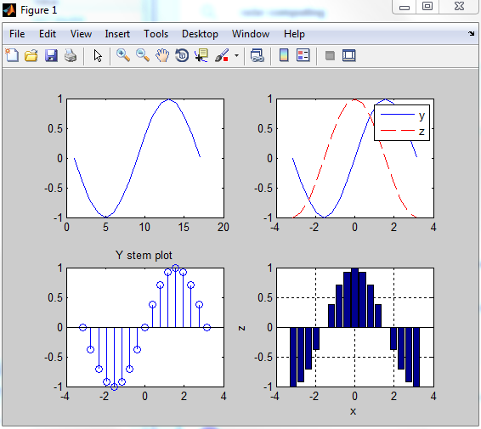

An example of Matlab plotting output from processed radar telemetry

